**

**IUBATInternational University of Business Agriculture & Technology**

**Report**

**on**

**“Project-Online Shopping"**

This report is prepared for partial fulfillment of CSC 383 – Programming Language JAVA

Prepared For:

Safwana Haque

Course Instructor

Department of Computer Science and Engineering

IUBAT – International University of Business Agriculture and Technology

Prepared By:

Group – C1

Spring 2019

**Submission date:7th April 2019**

7 April, 2019

To

Safwana Haque

Lecturer

Dept. of Computer science and engineering

IUBAT- International University of Business Agriculture & Technology

4 Embankment Drive Road , Sector-10, Uttara Model Town,

Dhaka-1230,Bangladesh

Subject: Submitting a report on “Online Shopping”.

Dear Ma’am,

With you respect, we would like to approach you that, we have completed the project on “Onling Shopping”. By this project we have learned a lot about a professional working style and also building this project has increased our technical knowledge.

We express our heart full gratitude to you through this report and hope you will find this report relevant. It would be very kind of you, if you please evaluate our performance regarding this project.

Sincerely

……………………………….

Name:Sagor Howlader

ID:17103184

**STUDENT DECLARATION**

We do here by declare that the report on “ Online Shopping” is a presentation of our original work. Wherever contribution of others involved, every effort is made to indicate this clearly, with due reference to the literature, and acknowledgement of collaborative research and discussions.

The report and The project on “Online Shopping” is originally prepared by our group with help of Internet. All module and procedure of this project is made after proper inspection and internet information.

Group Name:C1

|  |  |  |
| --- | --- | --- |
| ID | Name | Signature |
| 17103047 | Sumaya Akter |  |
| 17103048 | TanjinaJannatTithy |  |
| 17103184 | Sagor Howlader |  |
| 17103070 | MD JANNATUL NAYEEM RAJ |  |

**Program: BCSE**

**Semester: Spring2019**

**Department of Computer Science and Engineering, IUBAT**

**Contents**

Abstract*…………………………………………………………………………….*

Introduction*……………………………………………………………………….*

Project Aim and Objective*……………………………………………………….*

Functionality*……………………………………………………………………….*

UML Diagram*……………………………………………………………………..*

Working Screenshots *………………………………………………………………*

Requirement Analysis *……………………………………………………………*

Customer requirements*………………………………………………………….*

Data Requirement………………………………………………………….

Limitation*…………………………………………………………………………*

Conclusion*…………………………………………………………………………..*

Reference*…………………………………………………………………………….*

**Abstract**

The business-to-consumer aspect of electronic commerce (e-commerce) is the most visible business use by morden world. The primary goal of an e-commerce application is to sell goods product to customer. This project deals with developing an e-commerce application to sell products to customer. It provides the user with a catalog of different product available for purchase in the store. In order to facilitate online purchase a shopping cart is provided to the user. The system is implemented using a 3-tier approach, with a backend MySQL database, a middle tier apache server and a desktop application as the front end client. In order to develop online shopping application use JAVA SE and relational database MySQL. This is a project with the objective to develop a basic application where consumer is provided with a shopping cart application and also to know about the technologies used to develop such an application.

**Introduction**

Shopping has long been considered as a refreshment by many. Shopping in online became a recreational activity of life. The reason of developing application of online shopping system is everyone walking down the street has some difficulties, also some people are so much busy and not able to go out for shopping, some don’t like to shop in crowd. There is another reason that it’s not possible to see all the product of a store, also its hazardous for both the customer and the seller. The world of software development there lots of improvement in this area and to reduce the complexity of people of life online shopping system development. Online shopping system is a virtual store on Internet where customer can browse the product and select the product of interest. The selected product may be collected in shopping cart. At checkout time the items in the shopping care will be presented as an order. At that time shipping information and payment method have to select to the customer. Finally by confirming the order have to complete the shopping and the product will deliver to customer via currier, post office or by direct agent of company.

**Project Aim and Objective**

The objective of the Shopping systems is to increase the point of customer choice, reduce time used in shopping and efficiency in buying product.

* To develop an easy way to use desktiop interface where users can search for product view the details of the product and order it without going to market.
* The searching product can be done by product category, manufacturer as well as latest product, view it purchase it become a convenient way for customer.
* Customer can add product to cart to purchase.
* A user can view the complete specification of the product with various images and also view the customer review the product.
* It minimize the shopping time of customer, increase the point of choice. 2
* It also facilitate the service provider to know the current stats of market and take decision which product are selling more now a days and have to keep in store.

.

**Functionality**

Following are the scope of the developed systems:

**For Customer:**

**Registration:** Customer have to register to buy product.

**View Product:** Customer can view product according to category, manufacturer and latest product. Select the items to cart,he can also view product details, shipping info and price that means all in invoice.

**Shipping Information:** Customer have to give the product delivery location.

**For admin:**

**Category:** admin can add category, view, publish, unpublished, edit and delete category.

**Manufacturer:** admin can add manufacturer, view, publish, unpublished, edit manufacturer and delete manufacturer.

**Product**: admin can add product, view, publish, unpublished, edit manufacturer and delete product. Product delivery status: Admin can update sold product status.\

**UML Diagram**

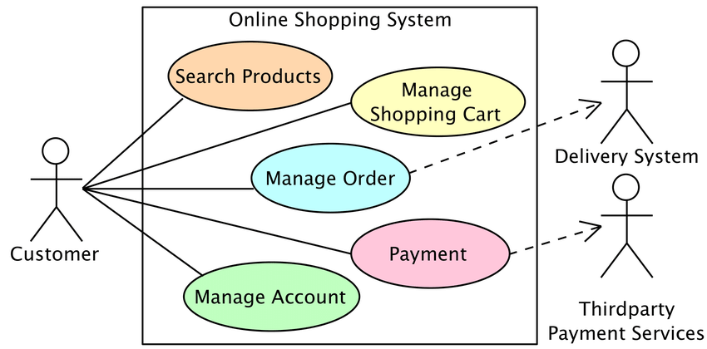

**Working Screenshots**

HomePage:

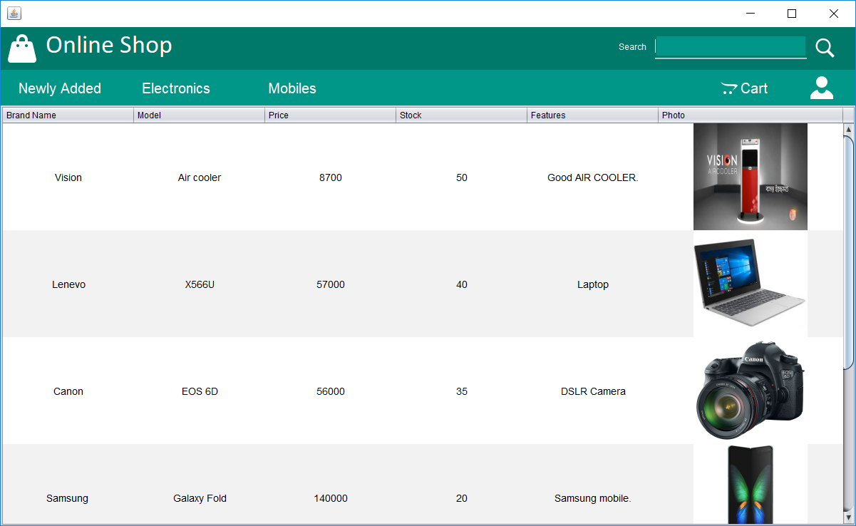

Restration and Login:

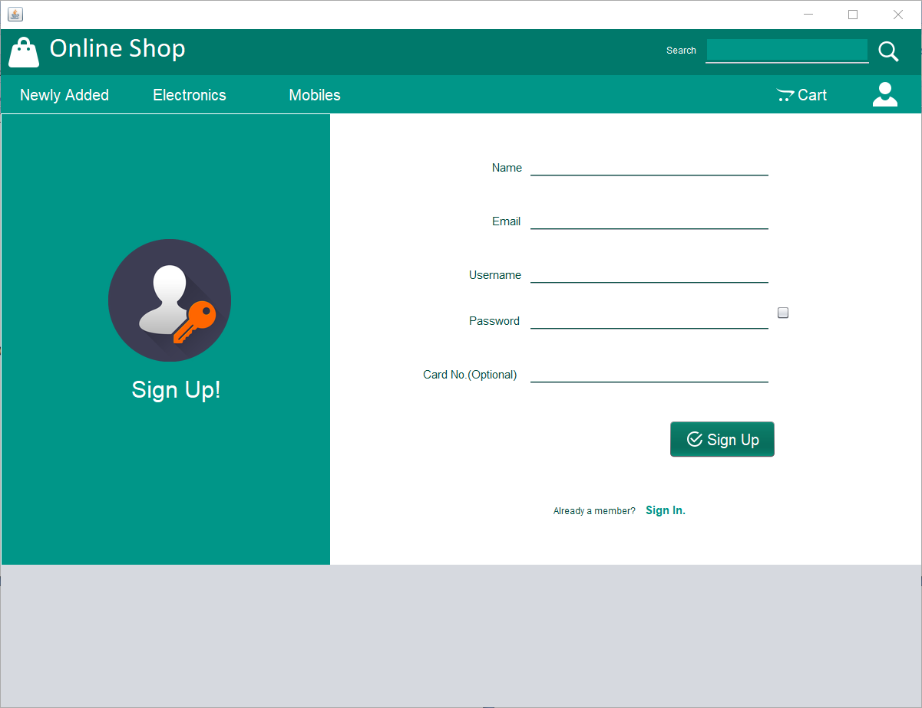

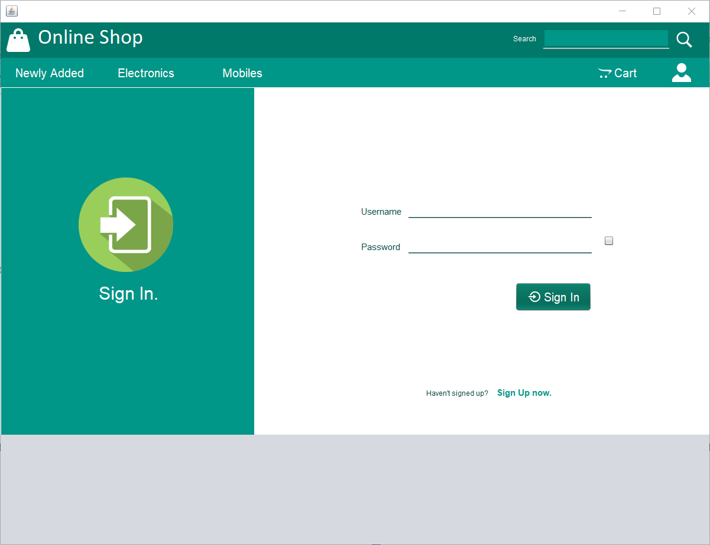

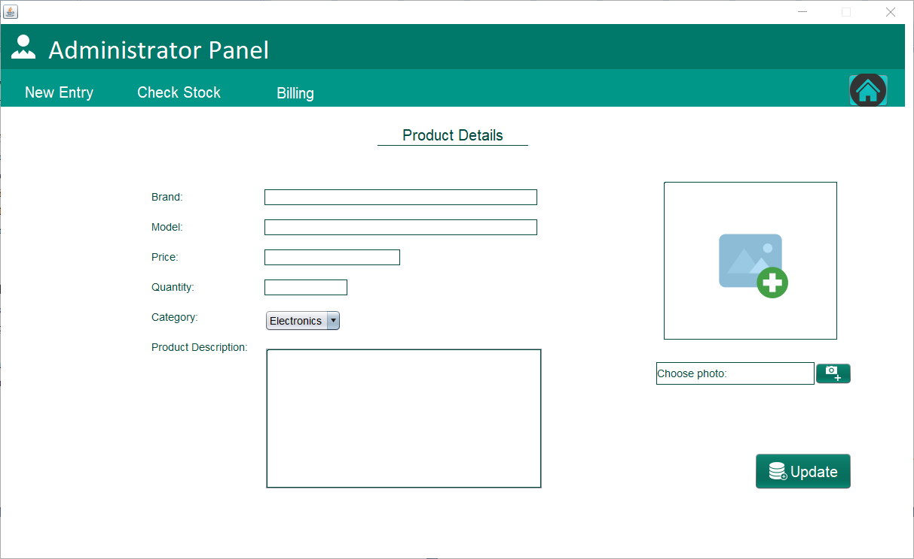Admin Panel:

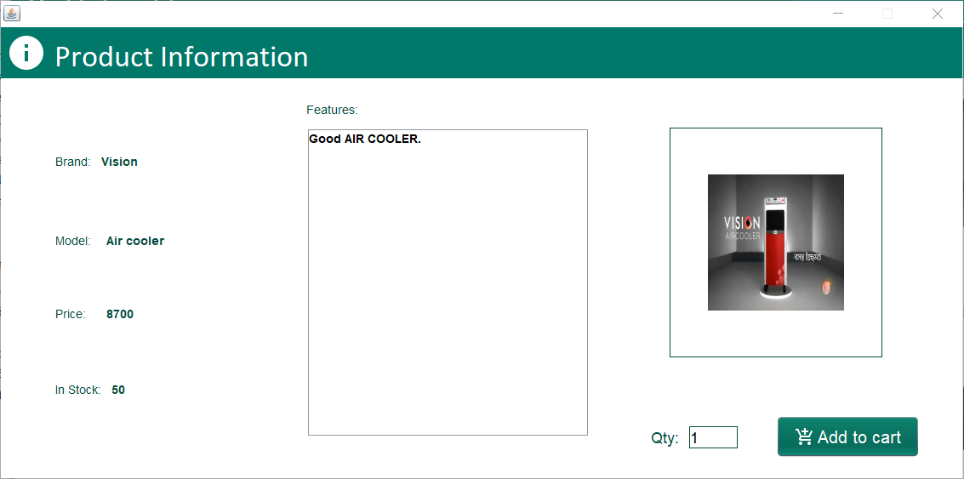

Product Information

Cart

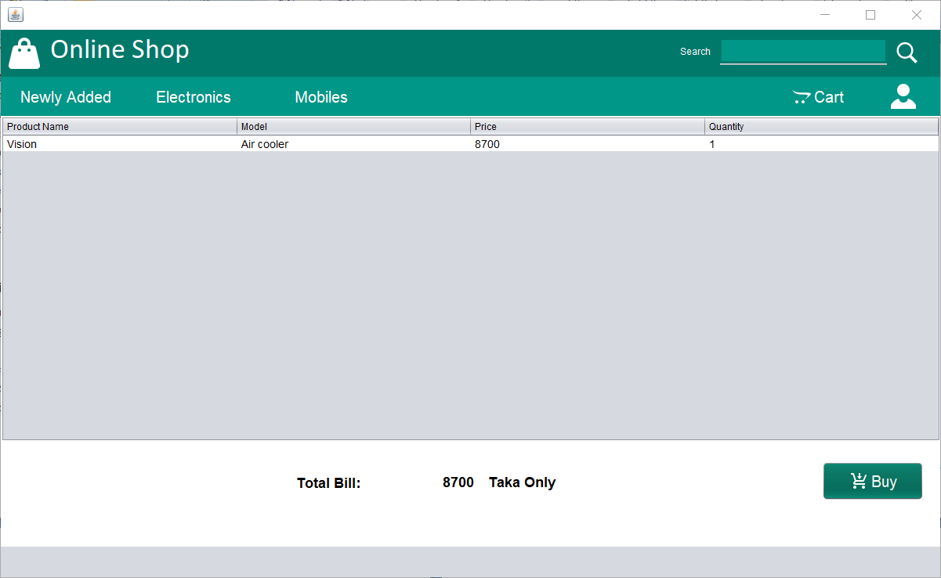

**Requirement Analysis**

As the goal of the application is ease of use and to provide an interactive interface, extensive research has been done to gain an insight into the needs and behaviors of various users. The working of the application is made convenient and easy to use for the end user. In desktop based shopping systems there are two party who interact with the system, one of them are customer who wants to buy product and other the system admin manage the system. A good web based online shopping system should present the following factors to the customers for better usability.

**Customer requirements:**

* Knowing when an item have to save not save in the shopping cart.
* Returning the different parts of the site after adding an item to the shopping cart.
* Easy scanning and selecting items in the list.

• Effective categorical organization of the products.

• Simple navigation from home page to information and order links for specific products.

* Obvious shopping links or buttons.
* Consistent layout of product information
* A well-organized web interface to work as admin so that he can handle all the part of the system properly.

**Data Requirement:**

* A customer can view the product properly but to buy he has to add the product in shopping cart, for this he has to register or have to login if he is an existing user.
* To launch the system, admin have to select the category of product, company or manufacturer of product will remain in the system for customer view and he can select those from his panel

**Limitation:**

* Can’t be update or edit Customer Information
* Cart select product can’t be edit and update
* No payment Method speratitly

**Conclusion:**

This is a desktop application where customers can buy goods as their requirement**.**

**Reference:**

[**https://stackoverflow.com/**](https://stackoverflow.com/)

[**https://github.com/**](https://github.com/)

[**https://youtube.com**](https://youtube.com)

[**https://google.com**](https://google.com)